SH707 Intelligent open flash point tester
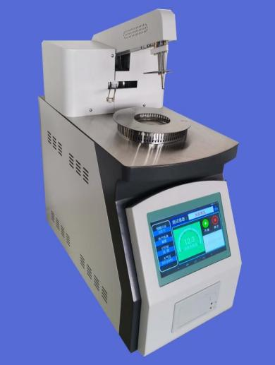

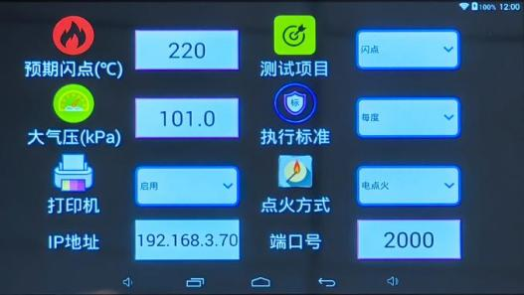

SH707 intelligent open flash point tester adopts the combination of microcomputer technology and Android system, with large screen LCD display. The instrument is heated up, automatically raised and lowered, automatically ignited, automatically displayed, automatically locked flash point value, and automatically printed results according to the standard method. After the test, it can automatically cool down and realize the full automation of the working process. It is widely used in power, petroleum, chemical, commodity inspection, scientific research and other departments. Comply with GB267-1988; GB3536-2008; ASTM D92.
High definition color touch screen, Android operating system and Internet plus technology are used to make the display content more colorful. You can surf the Internet, download documents, browse electronic user manuals, etc., improve the human-computer interaction ability, and make the operation more convenient. The product has added local control, and the data storage capacity reaches 1G. The electrical control and mechanical structure adopt the modular design of new technology, which makes the product durable, solid, safe and reliable in operation. The product appearance adopts industrial design to make the product have modern aesthetic feeling.
Features
● 7-inch color touch screen, human-computer dialogue interface in full Chinese, keyboard without logo
● Android operating system, internet access, download, LAN control
● It can connect mobile phone software for remote operation control, real-time synchronization and data export
● Automatically detect the atmospheric pressure and correct the influence of atmospheric pressure on the test and calculate the correction value.
● Detection method: differential detection of detection loop
● The ignition, detection and printing data are automatically completed, and the test arm automatically rises and falls.
● Electronic ignition, forced air cooling, automatic ignition without air source.
● Flash point and ignition point of test sample, one machine for two purposes
● Printer: equipped with micro printer
● Historical data: a single machine can store 1000 pieces of data
● Air pressure detection device: it is equipped with air pressure detection device to automatically correct atmospheric pressure.
● It can automatically ignite without air source, which improves the safety of the test.
● Clock display (power down hold)
● Excel form can be exported via mobile phone, stored in computer for a long time, and data can be saved indefinitely
Technical parameter
Temperature range | room temperature+5 ℃ - 400 ℃
Temperature measurement | PT100 platinum resistance (Class A)
Accuracy | ± 2 ℃
Resolution | 0.1 ℃
Repeatability | ≤ 4 ℃
Display mode | large screen color LCD display
Operating system | Android system
Data capacity | 1G
Ignition mode | electric ignition
Cooling mode | built-in strong air cooling forced air cooling
Printer | thermal, Chinese characters, 40 lines
Self-inspection function | test head, mixer, cover, fan, igniter
Power consumption | <500W
Working voltage | AC220V ± 10% 50 ± 5HZ,
Applicable ambient temperature | 5~40 ℃
Applicable ambient humidity | 30-80%
Printer | thermal sensitive, 36 characters, Chinese character output
Instrument size：480 × 250 × 450mm Weight: 15Kg
Package size: 550 × 305 × 575mm Weight: 20.4Kg

Packing list

S/N | Name | Quantity | Unit | Remarks
1 | Host | 1 | set
2 | Sample cup | 1 | Piece
3 | Wifi antenna | 1 | Piece
4 | Power cord | 1 | Piece
5 | Safety tube | 2 | piece | 10A
6 | Printing paper | 2 | roll
7 | Instruction manual | 1 | Copy
8 | Certificate | 1 | Copy
9 | Packing list | 1 | copy

